EXNO: 2
Analysis of SWR (Standing Wave Ratio) Transmission Lines by varying a) load impedance b) characteristic impedance
TEST CASE 1
Analyze the SWR of a transmission line for a fixed characteristic impedance (Zo) of 50
ohms, as the load impedance (ZL) is varied across 650 ohms to 850 ohms. Verify how the
SWR changes with each value of ZL. When ZL=Z0, the SWR should equal 1 (indicating no reflection).
OUTPUT:
Zo=50 ohmsVariable:ZR
S.No | (Z_L) (Ω) | Simulation SWR | Theoretical SWR
1 | 650 | 19.96 | 13.00
2 | 700 | 20.46 | 14.00
3 | 750 | 21.03 | 15.00
4 | 800 | 21.65 | 16.00
5 | 850 | 22.32 | 17.00

ZR=50/_40oohmsVariable:Zo
ZO Ohms | Simulation results | Theoretical results
 | SWR | SWR
650 | 2.04 | 1
700 | 1.94 | 1
750 | 1.86 | 1
800 | 1.79 | 1
850 | 1.73 | 1

Simulation Results:
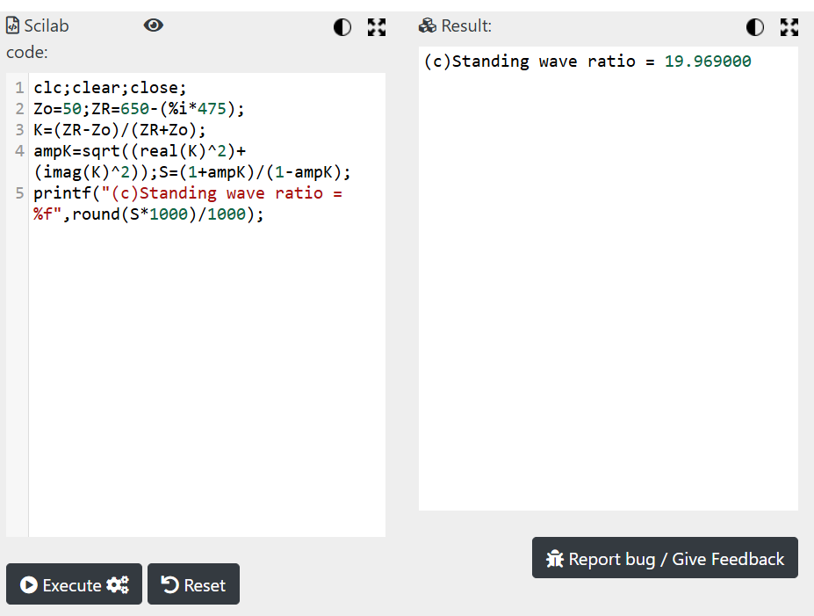
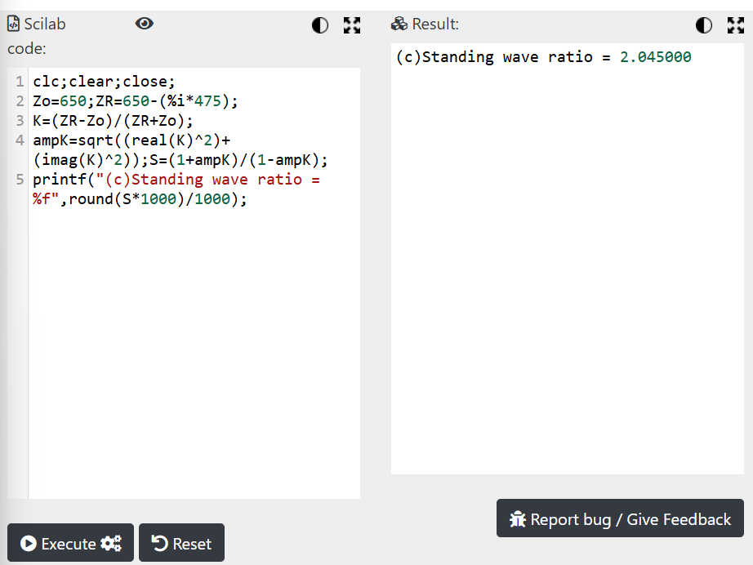

Theoretical Results:
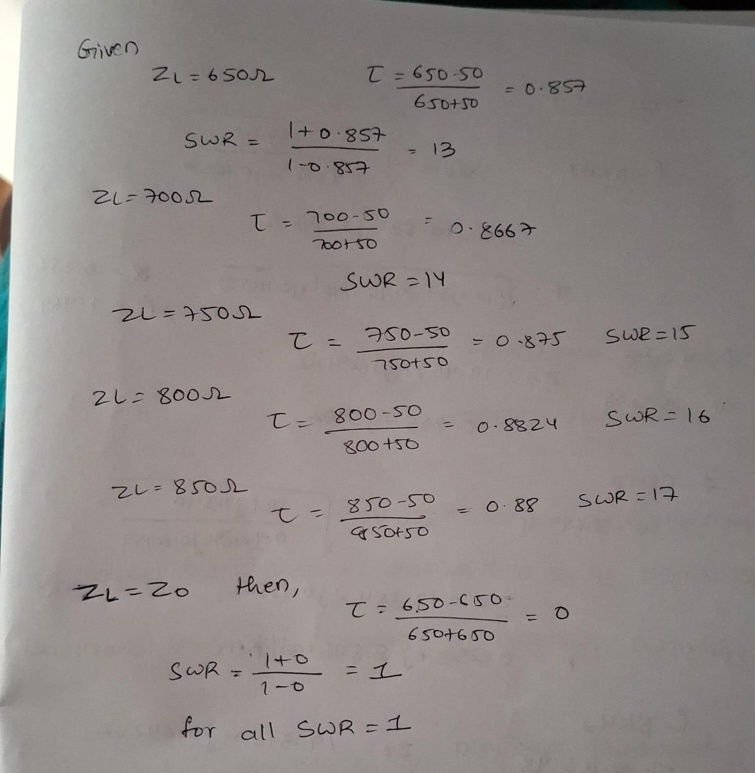

Test Case 2:
Analyze the SWR for a fixed load impedance (ZL) of 50 ohms while varying the
characteristic impedance (Z0) of the transmission line to 250 ohms to 400 ohms. Verify how
the SWR changes with each value Z0 including Z0=ZL.
OUTPUT:
ZR=50/_40o ohms Variable: Zo
S.No | (Z_0) (Ω) | Simulation SWR | Theoretical SWR
1 | 50 | 1.00 | 92.23
2 | 250 | 5.00 | 23.20
3 | 300 | 6.00 | 21.16
4 | 350 | 7.00 | 19.98
5 | 400 | 8.00 | 19.35

Simulation Results:
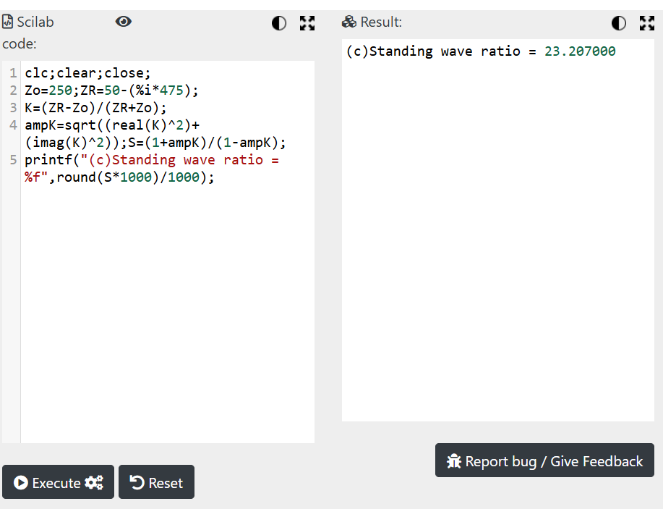

Theoretical Results
